**EmployeesPage.xaml.cs**

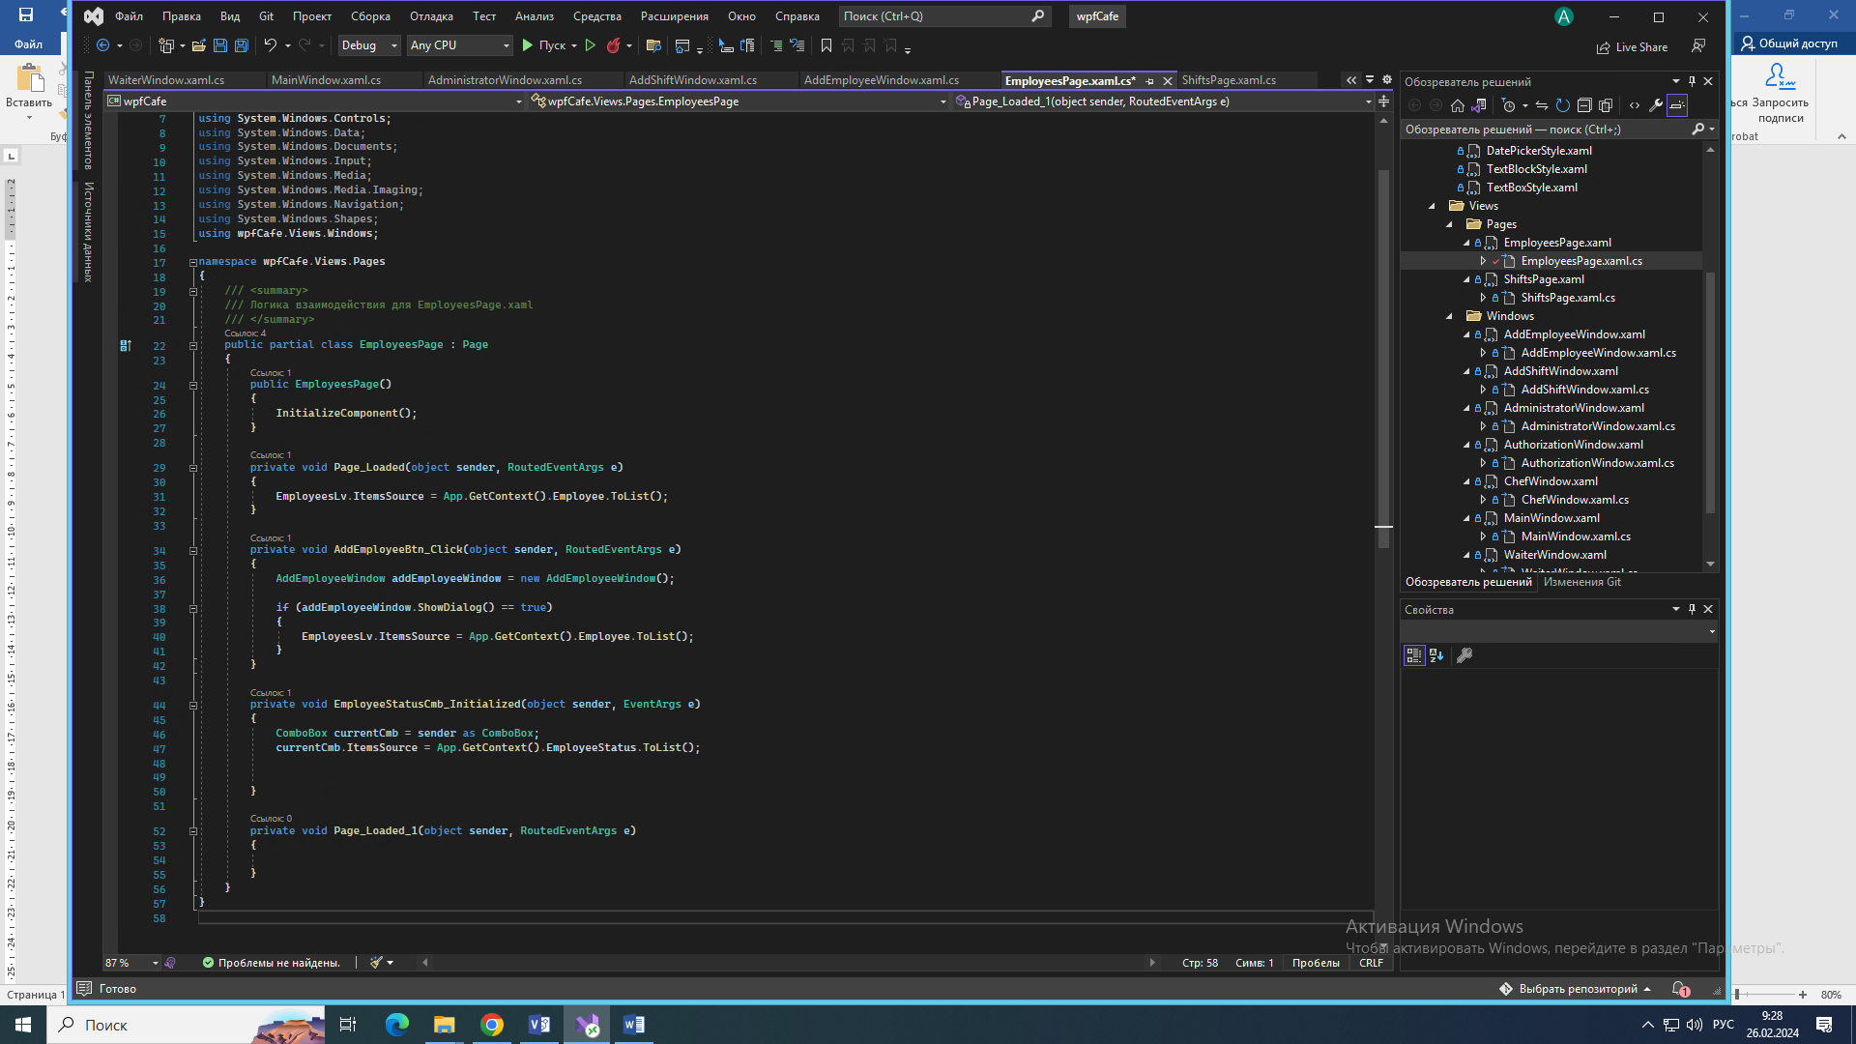

**ShiftsPage.xaml.cs**

